**ROAD LANE LINE DETECTION**

Name : VADDI SIVA NAGA SAI Email : [sivanagasaivaddi@gmail.com](mailto:sivanagasaivaddi@gmail.com)

Domain : AI-ML Ph no.: 7075405923

Task-1: Road lane line detection system

**Abstract :**

A road lane line detection system using machine learning (ML) enhances vehicle safety by accurately identifying lane boundaries. The system leverages computer vision techniques and ML algorithms to process real-time video feeds from vehicle-mounted cameras. By training on large datasets of road images, the ML model learns to detect lane markings under various conditions, such as different lighting and weather. The detected lanes are then highlighted, aiding in autonomous driving and driver assistance systems. This technology significantly improves lane-keeping performance, reduces the risk of accidents, and is a crucial component of advanced driver-assistance systems.

**LIBRARIES USED:**

OpenCV - pip install opencv-contrib-python

Numpy - pip install numpy Files Used: Road.png

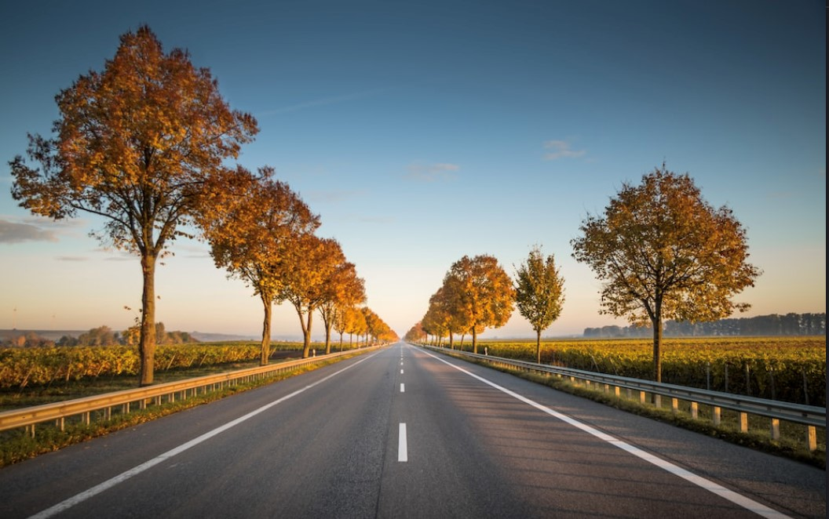

**IN THIS FILE I WILL DETECT ROAD LINE**

(Without video capturing) Code-1 (without live video capturing)

**INPUT :**

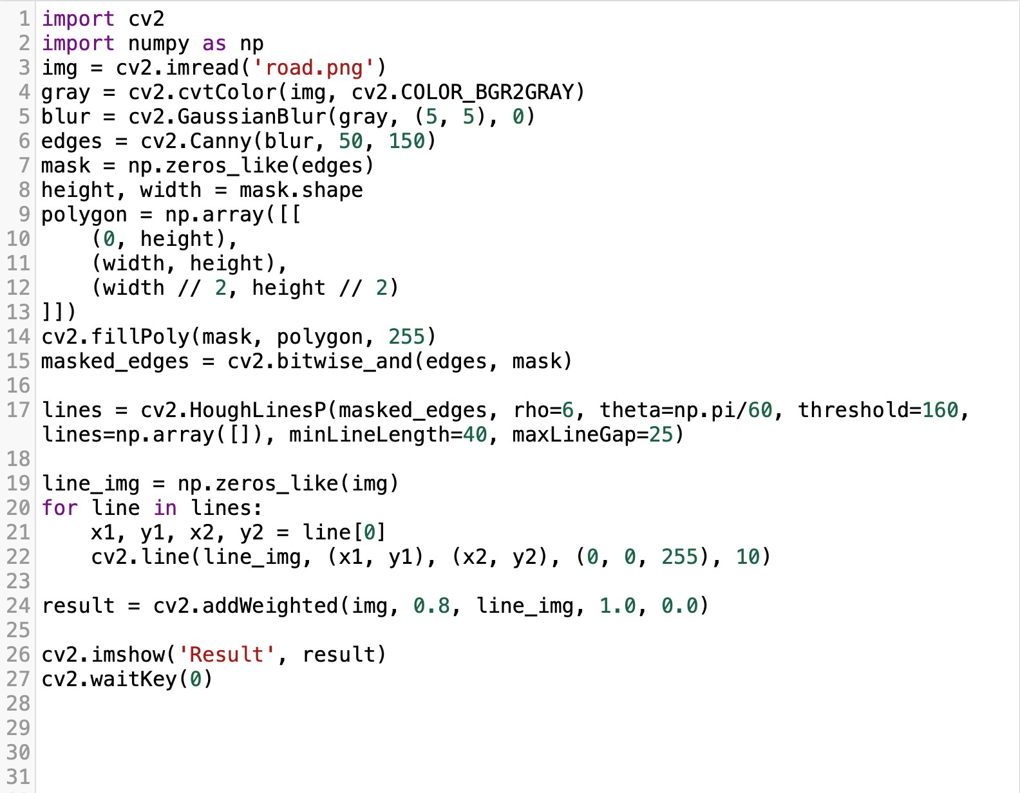

# OUTPUT:

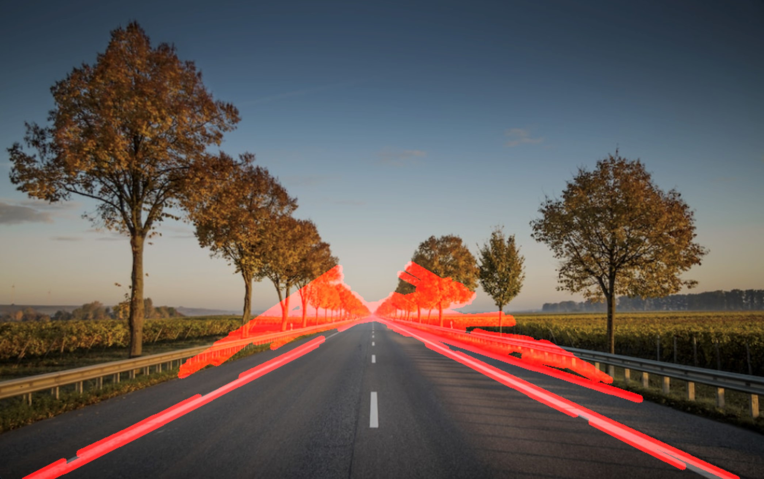

**Screenshot of the code:**

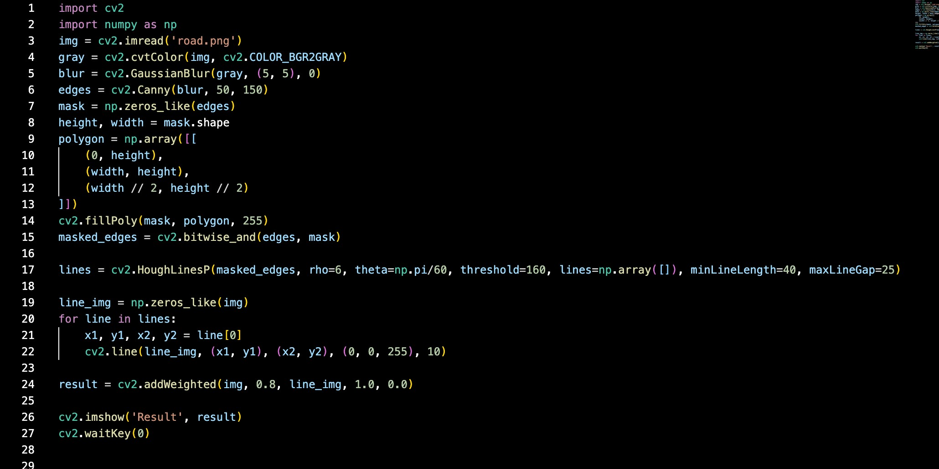

# Code-2 ( with live video capturing)

**INPUT:**

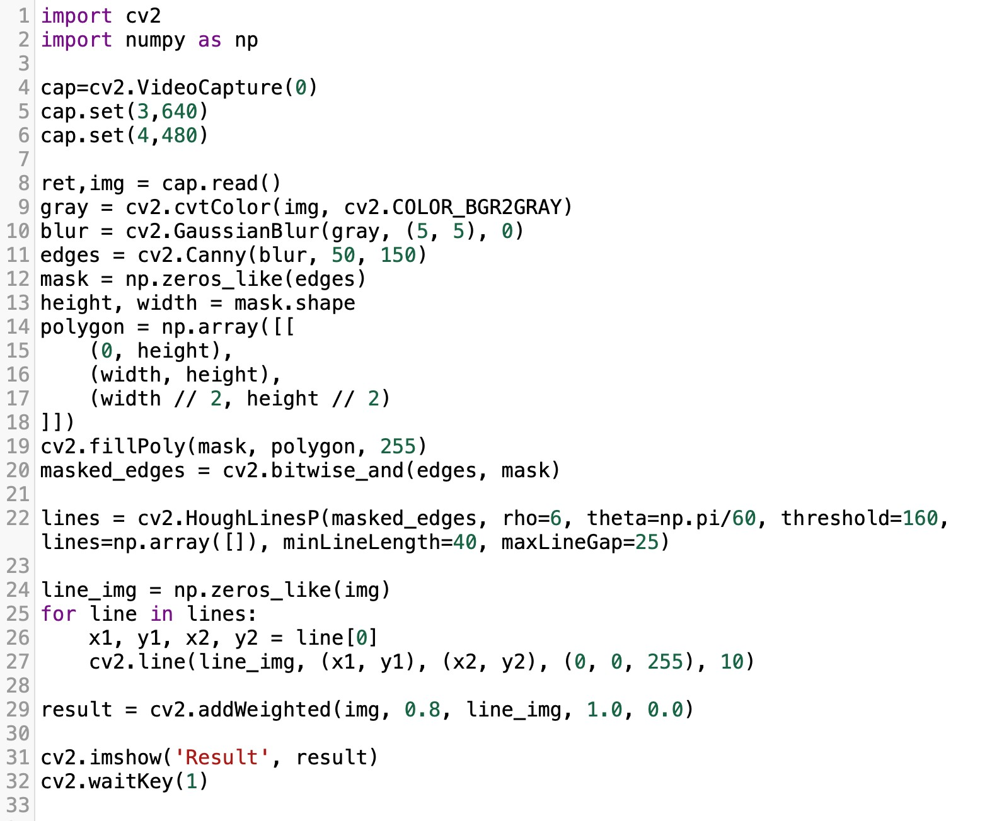

**OUTPUT:**



**Screenshot of the code:**

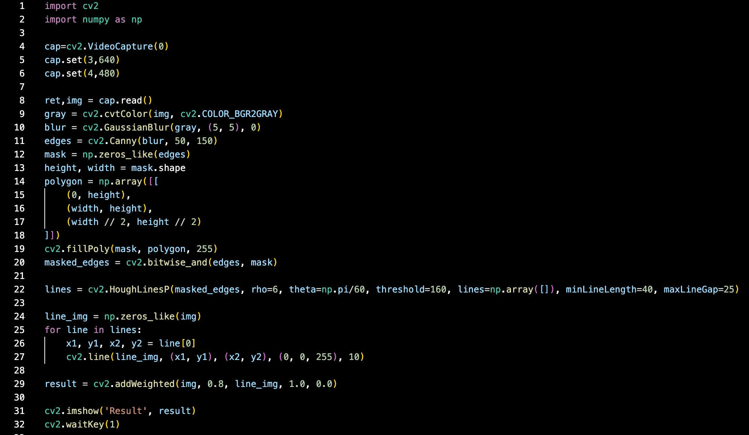

**THANK YOU!**